Contents
Quick Informer 5 (I5) User Notes 1
Filter a Dataset 1
Create a Report 4
Extras 5

*Note: This is fluid document – information may be added or deleted as updates occur. Use the link to this document for the most up to date information.

Quick Informer 5 (I5) User Notes

All the data you need will be in a dataset. For example, if your dataset is term-based, it will include all terms in Colleague.
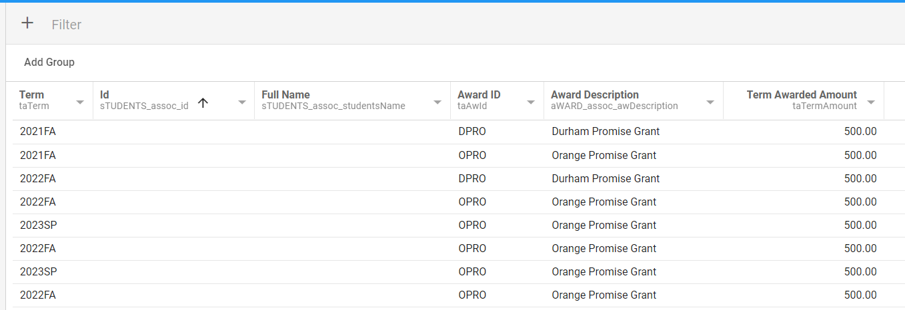
Be sure to check when the dataset was last refreshed on the bottom left corner of the screen.
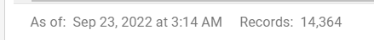
There are two ways to narrow down the data to the specifics that you need.

Filter a Dataset
One way is to use the filter button on the dataset.
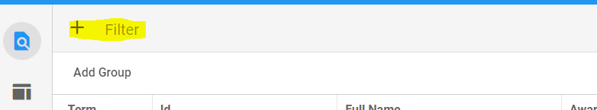
To use the filter option, click the + sign next to the word Filter in the top left corner. 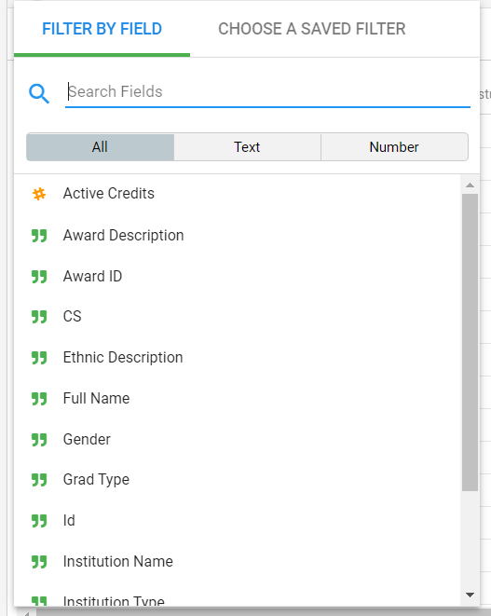
Search or scroll through the variables to choose how you want your data filter.

In the example below, the Term and 2020FA was chosen. Now the dataset will only show data from 2020FA. The green bubble at the top will tell you how the dataset is filter. You can add more than one filter at a time. Click the X on the green bubble to remove the filter.
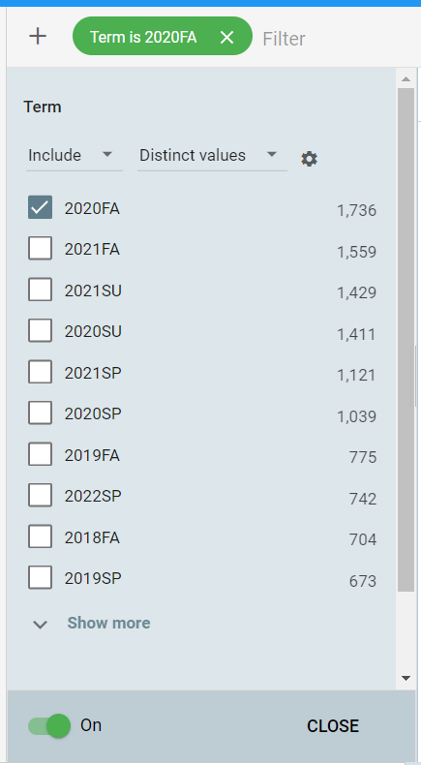
I5 also allows more ways to filter than the default. You can filter by including or excluding a variable.
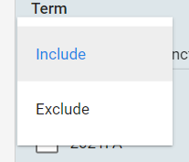
You can also change how you find the parameters for your variable. Examples: You are search for a specific student and you know their ID. Choose Enter Value and you can input the ID. If you know the part of the student’s last name, choose Like (uncheck exact match) and type in what you know of the student’s name. Want to find all the blanks on a particular variable or want to exclude all the blanks? Choose Is empty or Is not empty.
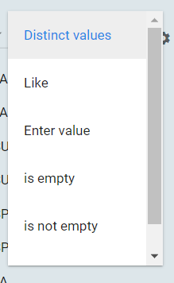
To export your filtered data (or the entire dataset), click the three dots on the top right corner and click export.
Export will give you several options to choose from:
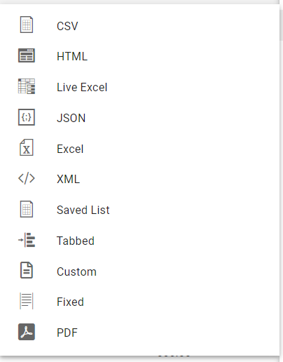
IMPORTANT – Be sure to click Apply Formatting if your data is filtered. The entire dataset will download if not.
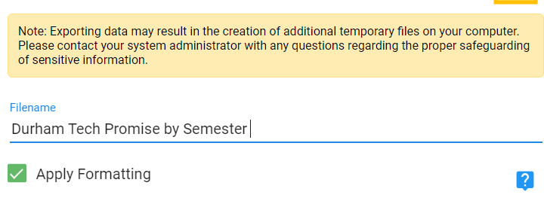

Create a Report
The second way to filter your dataset is to create a report from this dataset. (Think of a report being like what you normally ran in Informer 4, except in I5, you have a specific dataset like a specific chunk of Colleague.)
Note: If you do not have the option to create a report, please contact ITS through the work order system to request access.
To begin creating a report, click the three dots on the top right corner and choose 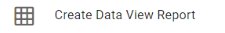
Choose a name for your report and click save.
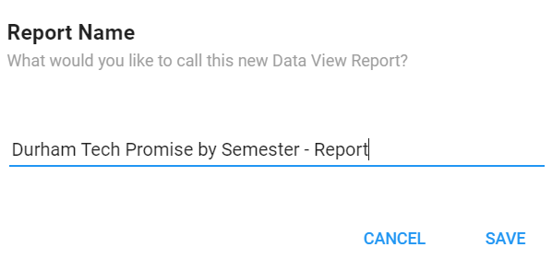
To filter the data as you need it, click the filter button in the top right corner. Similar to filtering a dataset, click the + sign to choose your filter.
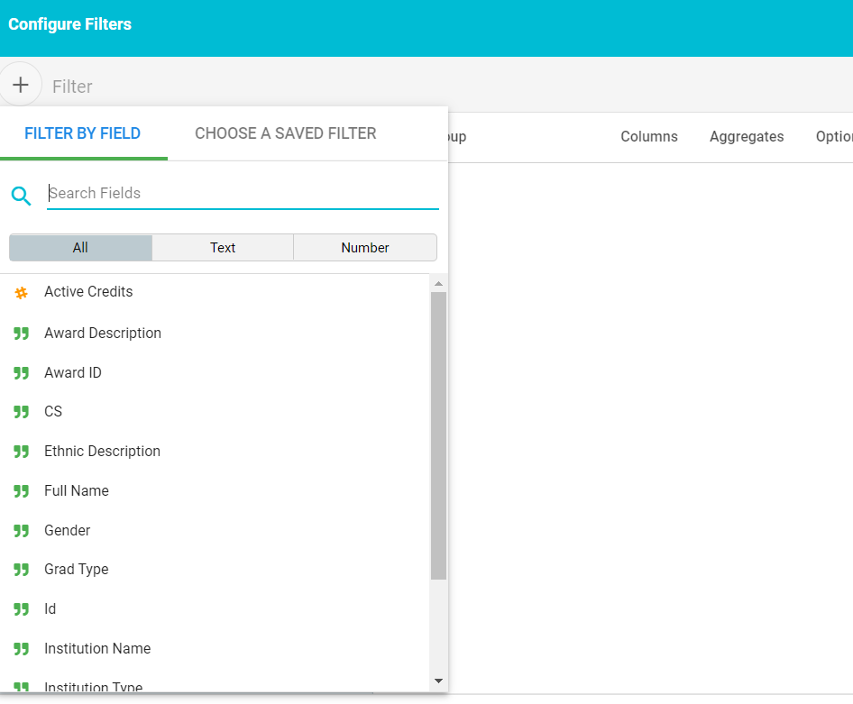
Click Apply when you have all the filters you need. Your data will now be filtered as requested. You can now export it in the same manner as a dataset.

Extras
The following steps are available in both datasets and reports. They are not necessary to use but can be useful.
1. Add Group in the top left corner.
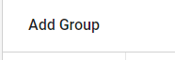
This option allows you to quickly group your data by a specific variable.
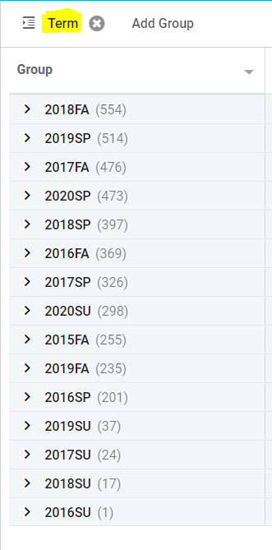
2. Columns in the top right corner.
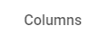
This option allows you to hide certain columns if they are not needed for your report.
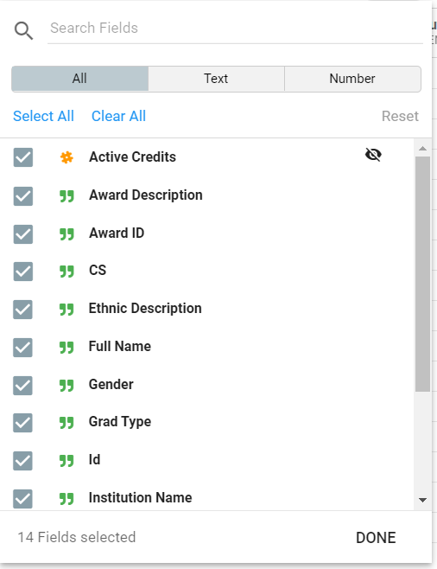

3. Aggregates in the top right corner.
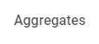
This option allows you to apply some descriptive statistics to your data. Choose the variable and the measure.
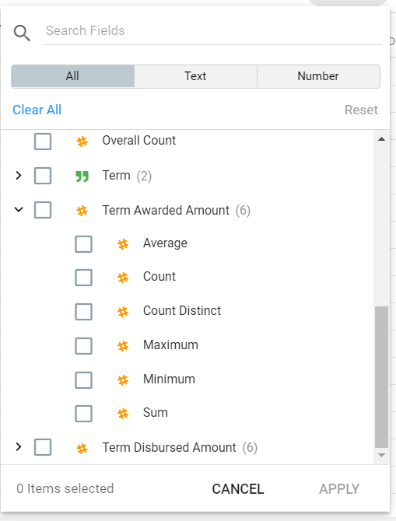

Example: Average Term Awarded Amount is chosen and will be displayed underneath the variable at the bottom of the report.
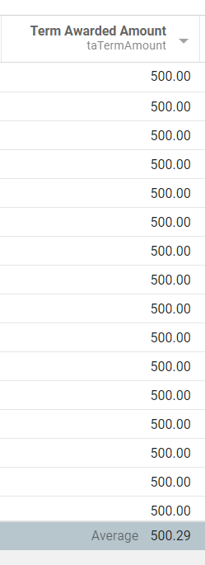
4. Options in the top right corner.
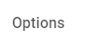
This allows you to hide field aliases and reveal fields that are hidden.
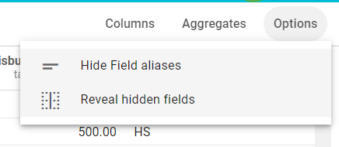

A field alias is the grayed code underneath the variable title.
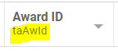

5. Pivot in the left sidebar.
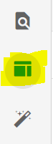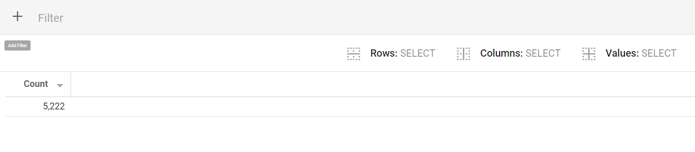
This option allows you to create pivot tables outside of Microsoft Excel. To learn about pivot tables, follow this link.
6. Discover in the left sidebar under Pivot.
This optional allows you to create and download some visuals of your data.
